Notes from Trinity Safety Allies presentation
1/27/24, Port Charlotte, FL
Mental Health in America
- 21% of adults are experiencing at least one mental illness. That's roughly 50 million people. 55% of adults with a mental illness have not received any treatment and one in five (20%) adults suffer from a diagnosable mental illness each year.
- Every day, approximately 123 Americans die by suicide. There were nearly two times as many suicides (45,979) in the United States as there were homicides (24,576). NIH
- About 70% of mental health challenges have their onset in childhood or youth. That's why early identification and intervention is so critical and can lead to improved achievement in school Sports, and better health outcomes in life.
- Depression. Impacting an estimated 300 million people, depression is the most-common mental disorder
- Data from the 2021 Adolescent Behaviors and Experiences Survey (ABES) indicate that 37.1% of U.S. high school students reported poor mental health during the COVID-19 pandemic, with 19.9% considering and 9.0% attempting suicide in the preceding year

Creating a Safety Plan:

- Develop an Emergency Operational Plan.
- Conduct training.
- Setting up a Safety Team.
- Situational Awareness/Threat Profiling.
- Verbal De-escalation.
- Laser Shot training.
- Recognize indicators of potential Church issues.

Issues Facing Churches
- Aggerated Battery
- Arson/Bomb Threat
- Brawl
- Burglary
- Domestic Violence
- Embezzlement
- Exposure
- Homicide
- Kidnapping
- Man with Gun
- Medical Emergencies
- Mental Health*
- Miscellaneous
- Robbery
- Sexual Battery
- Shootings
- Theft
- Vandalism

Safety Training
- Lost Child
- Kidnapped Child
- Medical Emergencies
- Disruptive Attendee
- Domestic Issues
- Fire
- Homeless/Panhandler
- Active Shooter
- Social Media
- Mental Illness
- Bomb Threat

Presentation to Church Members
- Must educate – Volunteers are the First Line of Defense
- Explain to them that they are an important part of this ministry
- See Something – Say Something
- Provide Training

Active Shooter Situations
- Unpredictable.
- Evolve quickly.
- Continue until stopped by law enforcement, suicide, or intervention.

Active Shooter Training
- Identify the sound of gunfire.
- React quickly.
- Call 911.
- What to expect when law enforcement arrives.
- Adopting a survival mindset during a crisis.



Concealed Weapon Carrier Information
- You are responsible to know and obey the concealed carry laws of the state of FLORIDA.
- We are not asking you to carry a weapon on the church property.
- If you discharge a weapon on the church property, you will not be covered under the ministry’s insurance policy and someone may file a lawsuit against you no matter what you do.
- You assume full responsibility for your actions and the impact on others when you carry a weapon, so please check with your homeowner’s policy about liability coverage for yourself.
- Please be aware that a bullet from a gun can travel through walls and possibly hit a person in a classroom or other location.
- Arriving law enforcement may consider anyone exposing a weapon as a deadly threat.
- You are responsible to secure your weapon at all times to prevent children or anyone from having access to it.
- In case of any incident, (designated ministry leadership person/s) is/are the only official spokesperson/spokespeople for the church.

Threat Profiling Defined
- It is a combination of time-tested, current trend profiling and behavior-patterning analysis.
- Relies on identifying typical human behavior patterns.
- This will allow you to detect a threat.
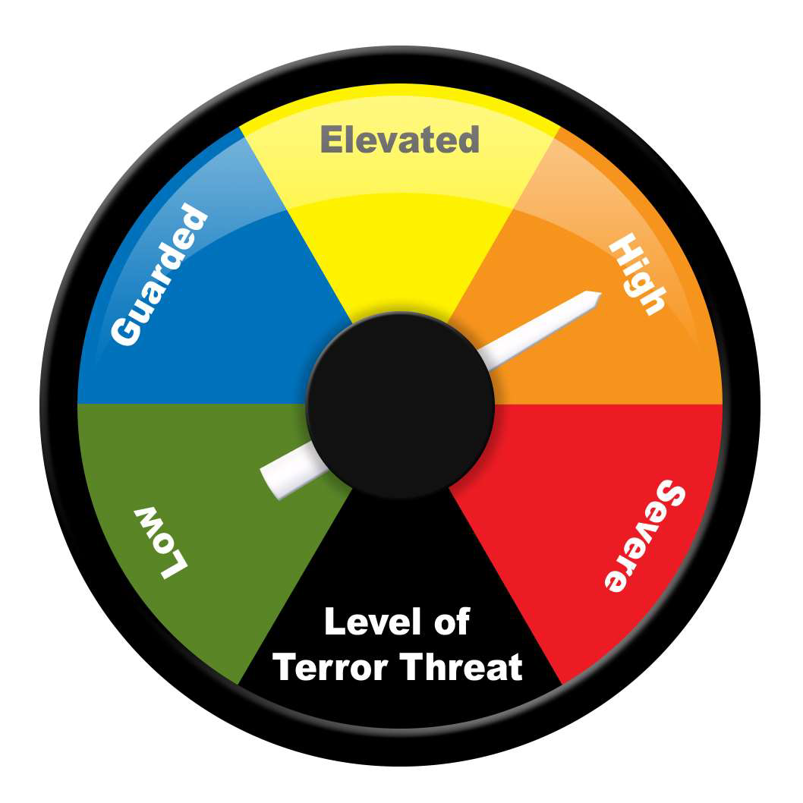
Threat Profiling Defined
- It is a method of proactively identifying possible threats through human behavior pattern analysis and recognition.
- Whatever the threat, there will be certain observable and measurable characteristics.
- Works on people, places and events.

Targets of Opportunity (soft target)
- They are looking for places with maximum payoff.
- They may do surveillance work on your church.
- May even conduct a trial run before the attack.

Anomaly
An anomaly is a deviation from the baseline, anything that rises above; something that is there that should not be there. Or it could be something that falls below the baseline; it is something that is absent that should be there.

Recognizing the Anomaly

- We develop file folders based:  perceptual and intellectual principles of observation.
- These file folders are developed through:
  - Your life experiences.

Rule of Threes or Clusters
- In most cases, a single cue is not enough to decide, unless that cue is an immediate threat to the Church.
- If three anomalies are detected, STM must make contact.
- Second STM should keep this situation under constant surveillance.

Action – O.A.R.
- Baseline + Anomaly = Requires a Decision
- We have Observed the Anomaly
- We must Assess the Anomaly
- Now we have to React

Action
- Threat – must be dealt with immediately.
- Contact another STM on what you have – get a second opinion.
- Contact Minister on Duty (MOD).
- STM should be the first contact if suspicious.

Threat Profiling Domains
- Heuristics
- Proxemics
- Geographic’s
- Atmospherics
- Kinesics
- Biometrics

Heuristics
- A Mental Shortcut that helps us make decisions and judgement quickly.
- It is an approach to problem solving that takes one’s personal experiences into account.
- Your heuristics allow you to think through the possible outcomes quickly and arrive at a solution that will work for your unique problem.
- These can be good or bad

Kinesics

Facial

Learned

Innate
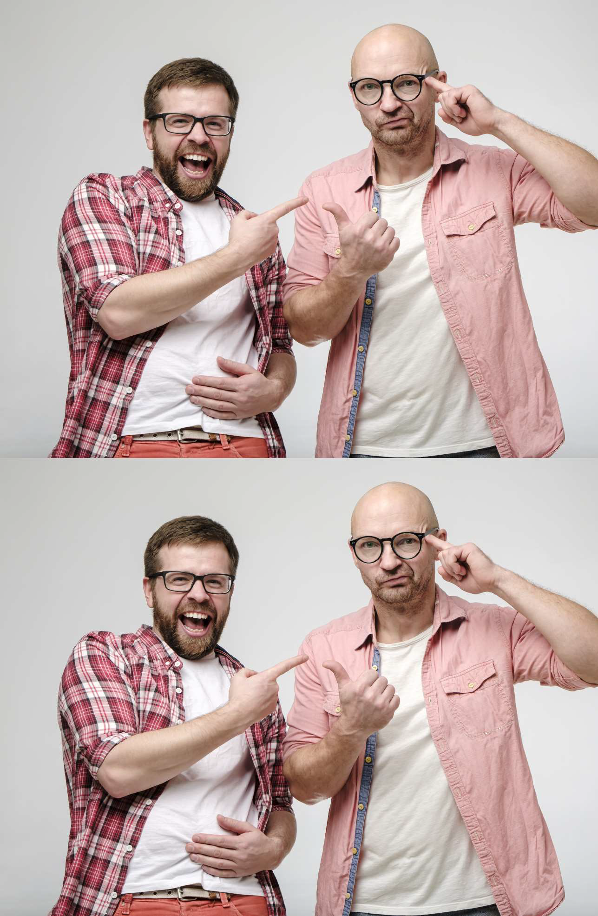
Mixed
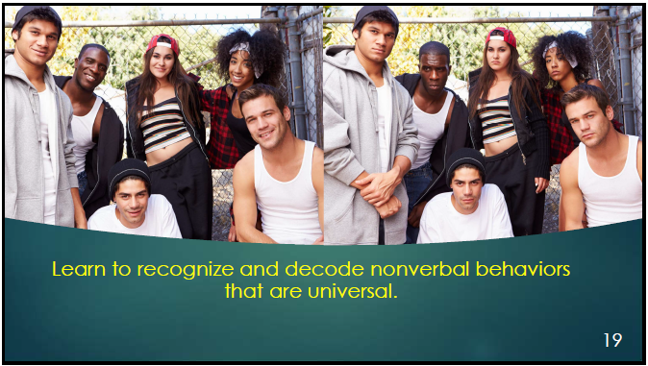



Examples of Body Language
- Scratching or rubbing the head.
- Running fingers through the hair.
- The placement of the hands on the hips.
- Rubbing or wringing the hands together.
- Balling of the fists.
- Tapping the feet.
- Direction of the toes indicates.

Considerations
- Kinesics is a very in-depth domain and several important items must be remembered.
- Establish a baseline before determining Kinesics.
- Kinesics must be read in clusters.
- Different people may have different Kinesics.
- Will tend to differ between genders.
- Culture effects kinesics, you must understand the culture before you can properly identify kinesics.

Biometrics
- Histamines
- Blushing in the face and ears when embarrassed is a histamine response.
- Extreme anger will cause reddening of face.
- Adrenaline
- Pulses can become visible in a persons chest and veins.
- Hands, legs, and even the entire body may start shaking.
- Pupil Dilation Constriction
- The pupil will dilate for a fraction of a second
- Both dilation and constriction will occur when under the influence of alcohol and narcotics.

Proxemics
- Proxemics is the act of betraying affiliations through the dynamics of proximity.
- Proxemics are not limited to the relationship between people, it can be applied to a person’s relation to things, places, and events.
- This happens at the unconscious, subconscious and conscious levels.

Relative Distances





Adoration

Mimicry

Person of Interest Indicators

Direction

Entourage29

Habitual Areas
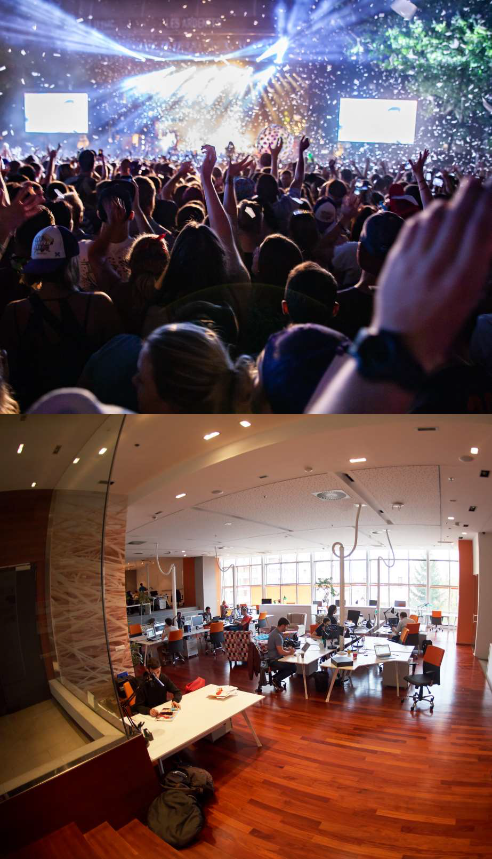 | 

Anchor Points
 | 

Atmospherics
Examples:
- Intoxicated, Suspicious or Homeless Person on Campus
- Person Crying Hysterically or Sitting Alone
- Not Participating:
  - Worship Service
  - Offering
  - Communion

Statement Analysis
- Statement analysis is a technique for analyzing the words people use to try to determine if what they said is accurate.
- Start a conversation
- Ask Simple questions
- Listen to their story
- Show Interest
- Show them respect
- Non-judgmental

